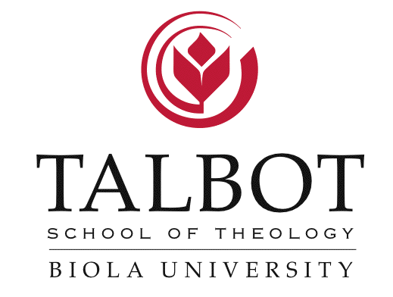

Assessing and Addressing [Student] Economic Challenges at Talbot School of Theology

:: Major Grant Program Outcomes
- Students in the Master of Divinity degree program will demonstrate knowledge and understanding of financial literacy, and use appropriate resources to minimize debt.

- Gains in student affordability will be shown by significant increases in scholarship funding for students enrolled in the Master of Divinity degree program.

- Collaboration with primary stakeholders will be indicated by cultivation of partnerships for their strategic import to the purposes of the grant program.

- Major grant program outcomes will demonstrate sustainability in integration of biblical and practical principles of financial literacy in student practices and in the curriculum, and in fundraising strategies.

:: Significant Project Activities To-Date
- Research preparation regarding aspects of financial literacy: created questionnaires to be sent to MDiv students, spouses, and alumni, and questions to be used in focus groups and interviews with randomly selected students, student spouses, and alumni.

- Conducted student focus group to identify obstacles in soliciting anonymous financial information from students and student spouses, and pretest student, spouse, and alumni questionnaires, focus groups, and interview questions.

- Interview with Talbot Field Education Director and Director of alumni support ministry regarding obstacles and resolutions in interacting with alumni regarding financial matters.

- Preparation of application for permission to conduct research on the campus of Biola University to submit to the Protection of Human Rights in Research Committee.

- Initiated bibliography of financial literacy and other financial resources.

:: Resources
- Auburn Theological Seminary, Center for the Study of Theological Education (CSTE), Finance and Student Debt: http://www.auburnseminary.org/research

- Denver Seminary, Financial Aid, Loan Management: http://www.denverseminary.edu/become-a-student/financial-aid/loan-management/

- FinAid: The Smart Student Guide to Financial Aid –
Financial Aid web page dedicated to helping those struggling to pay off debt:
http://www.finaid.org/loans/troublerepayingdebt.phtml

- National Student Loan Data System: http://www.nslds.ed.gov/nslds_SA/

:: Projector Director
- Dennis H. Dirks, Ph.D., Dean of Academic Administration
Biola University
13800 Biola Ave. La Mirada, CA 90639
562/944-0351, X3526
dennis.dirks@biola.edu 3.11.14

